A Multi-Player, Multi-Platform, and Protocol Independent Framework:

Developed for Games and Simple Networked Applications

Michael Richardson

Utah Valley University

Abstract

This project is to build multi-player and multi-platform space-themed games with a modular architecture, variety of supported network protocols, and elements of gameplay for both entertainment and education. My portion of the project is developing the framework in which these games will run. I defined requirements, designed, built and tested a server and game engine to run in Python on a Linux machine and clients to run on a desktop or on the web.

*Keywords: multi-platform, multi-player, games, protocol*

Project Report

Contents

List of Deliverables 6

Project Overview and Goals 7

License Information 9

Project Schedule 10

Detailed Description of Problem being Solved 11

Research Methodology and Findings 12

Overview of Design 13

Network Architecture 13

Client Logic 14

Server Logic 15

Game Engine Logic 16

Client-Server Protocol 17

Client-Game Engine Protocol 18

Client-Server Protocol 20

Discussion of Implementation 21

Problems Encountered 22

What was Learned? 23

Appendix I – Original Proposal 24

Project Proposal 25

Abstract 25

Detailed Description 25

Applicable Tools, Platforms and Standards 26

Licensing 27

Proposed Deliverables 27

Project Schedule 27

Project Details 28

Appendix II – Work Log 29

Appendix III – Requirements 30

Appendix IV – JSON Messages 31

Server – Game Engine 33

Server Session Inform (Server to Game Engine) 33

Game Inform (Game Engine to Server) 33

Success (Game Engine to Server) 33

Error (Game Engine to Server) 33

Success (Server to Game Engine) 34

Error (Server to Game Engine) 34

Client – Game Engine 35

Game Session Request (Client to Game Engine) 35

Game Session (Game Engine to Client) 35

Game Chat Message (Client to Game Engine | Game Engine to Clients) 35

Get Game Chat Message (Client to Game Engine) 35

Get Game Update (Client to Game Engine) 35

Game Update (Game Engine to Client) 36

Game Command (Client to Game Engine) 36

Terminate Game (Client to Game Engine) 36

Success (Game Engine to Client and Server) 36

Fail (Game Engine to Client and Server) 36

Error (Game Engine to Client and Server) 37

Client – Server 38

Server Session Request (Client to Server) 38

Server Session (Server to Client) 38

Server Chat Message (Client to Server | Server to Clients) 38

Get Server Chat Message (Client to Server) 38

Get Game List (Client to Server) 38

Game List (Server to Client) 39

Terminate Session (Client to Server) 39

Success (Server to Client and Game Engine) 39

Fail (Server to Client and Game Engine) 39

Error (Server to Client and Game Engine) 40

Appendix V – JSON Objects 41

Server 43

Game Engines 43

Game Engine 43

HTTP Clients 43

HTTP Client 43

Sever Sessions 43

Server Session 43

Users 43

User 43

Game Information List 43

Game Information 44

Server Chat Messages 45

Server Chat Message 46

Game Engine 47

HTTP Clients 47

HTTP Client 47

Sever Sessions 47

Server Session 47

Game Sessions 47

Game Session 47

Players 47

Player 48

Game 48

Game Updates 48

Game Update 48

Game Information 48

Game Chat Messages 49

Game Chat Message 49

Client 50

Game Command 50

Appendix VI – Presentation 51

# List of Deliverables

1. Project Source Code (GIT Repository)

2. Communication Libraries and Documentation (Finished and Polished)

3. Multi-platform game (Prototype)

4. Web Client (Prototype)

5. Desktop Client (Prototype)

6. Server (Prototype)

7. Game Engine (Prototype)

8. Final Project Report

9. Final Project Presentation

# Project Overview and Goals

This is a long-term project spanning multiple semesters with a modular architecture so students can work on modules independently or as part of a research group. The game will have a space theme and will incorporate aspects of role-playing, strategy, and 4x games (explore, expand, exploit, and exterminate).

My portion of the project is to define requirements, design, build and test libraries for clients and a server with a database for players, characters, and world (setting) information. The server will be written in python and will need to support HTTP traffic as well as sockets and web sockets. The database will store data as JSON objects in MongoDB. The API for the server will adhere to principles of HATEOAS and REST. I will be creating a central server program with libraries for database, communication and game logic.

The communication libraries will be built to support socket connections, JSON traffic and elements of the API and protocol(s). The protocol will include definitions of the types of data and their properties. TCP socket connections for both HTTP and real-time traffic. Players will be able to use a variety of clients including: desktop applications, native mobile applications, desktop and mobile browsers and SMS. These clients may use 3D graphics, 2D graphics, ASCII Graphics or just text, depending on the type of client and available network bandwidth. Some parts of the game will not be accessible every client (SMS being particularly limited).

I will develop a desktop client for Windows, one or more mobile clients and a web (browser) client. The desktop client will be using Visual Studio 2013 to build either be a console application or a WPF application. The mobile client will be will be built for Windows Modern, Windows Phone or Android. The browser client will be built to be compatible with all major desktop browsers (Chrome, Safari, Firefox and Internet Explorer).

The early prototype of the space-themed game will allow players to move around a map, collect items, achieve some victory condition and communicate real-time with other players. The objective of the server and client is to demonstrate the functionality of the libraries and protocol. Git will provide version control for all the project source code and documentation. The Source code will be released as open source under the Apache License.

# License Information

The source code is licensed under the Apache License, Version 2.0 as follows:

Copyright 2014 Michael Richardson

Licensed under the Apache License, Version 2.0 (the "License");

you may not use this file except in compliance with the License.

You may obtain a copy of the License at

http://www.apache.org/licenses/LICENSE-2.0

Unless required by applicable law or agreed to in writing, software

distributed under the License is distributed on an "AS IS" BASIS,

WITHOUT WARRANTIES OR CONDITIONS OF ANY KIND, either express or implied.

See the License for the specific language governing permissions and

limitations under the License.

# Project Schedule

January 6 – Gather and define requirements

January 13 – Gather and define requirements

January 20 – Design game and API

January 27 – Build Server communication library

February 3 – Build Server communication library

February 10 – Build Game Engine communication library

February 17 – Build Game Engine communication library

February 24 – Build Client communication libraries

March 3 – Build Client communication libraries

March 10 – Build Client communication libraries

March 17 – Design and implement database

March 24 – Refactor and test database

March 31 – Comprehensive refactoring and testing

April 7 – Comprehensive refactoring and testing

April 14 – Comprehensive refactoring and testing

April 21 – Prepare final report and presentation

April 25 – Final project presentation

# Detailed Description of Problem being Solved

ToDo:

# Research Methodology and Findings

ToDo:

# Overview of Design

## Network Architecture

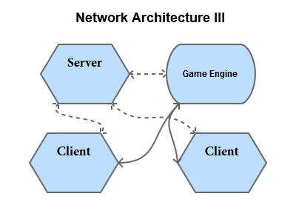

## Client Logic

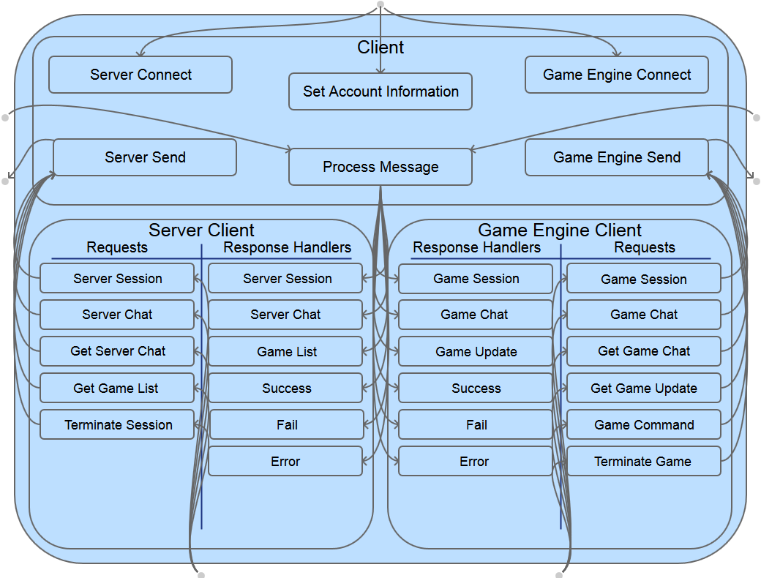

## Server Logic

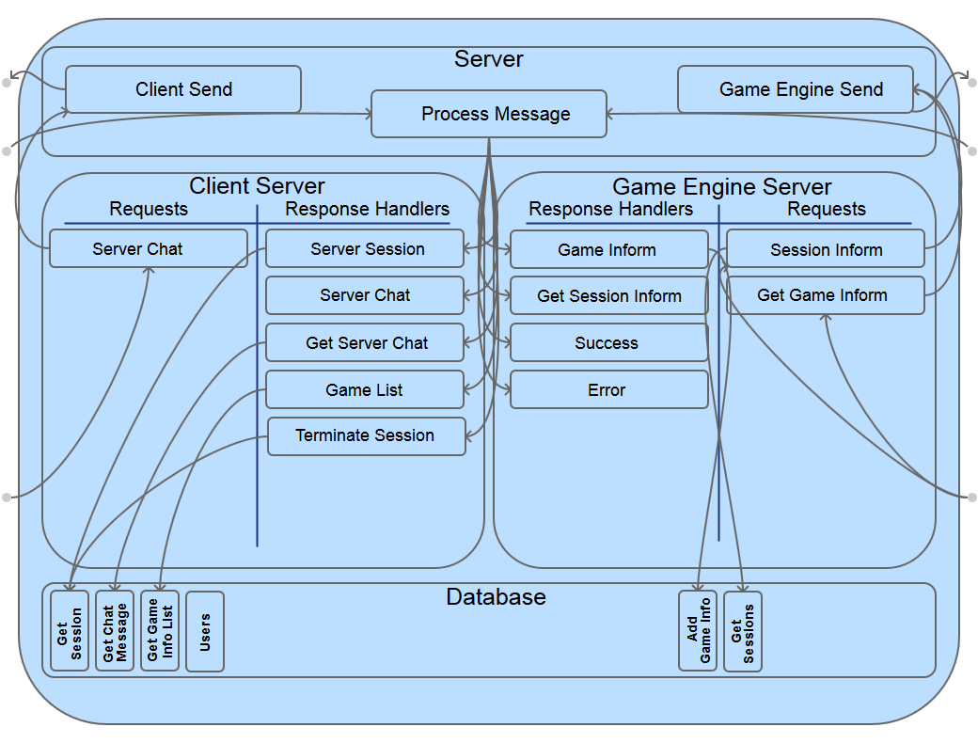

## Game Engine Logic

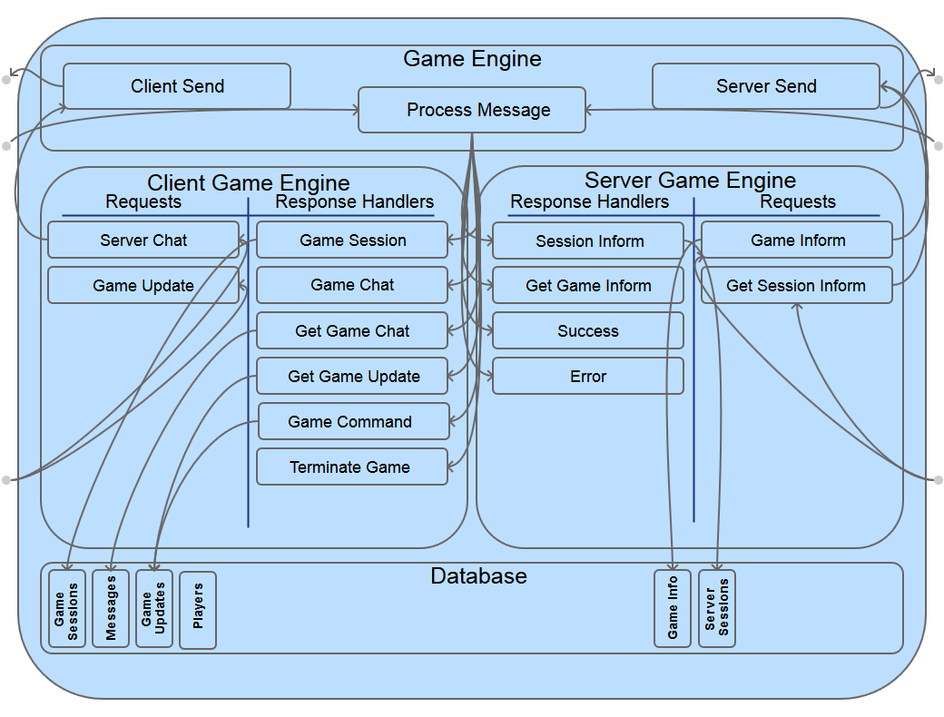

## Client-Server Protocol

**ToDo:**

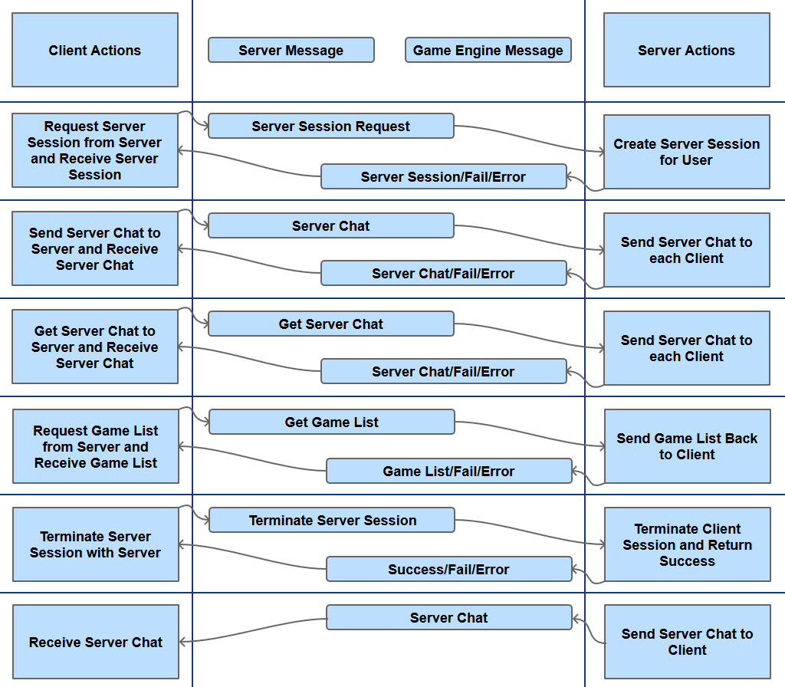

## Client-Game Engine Protocol

**ToDo:**

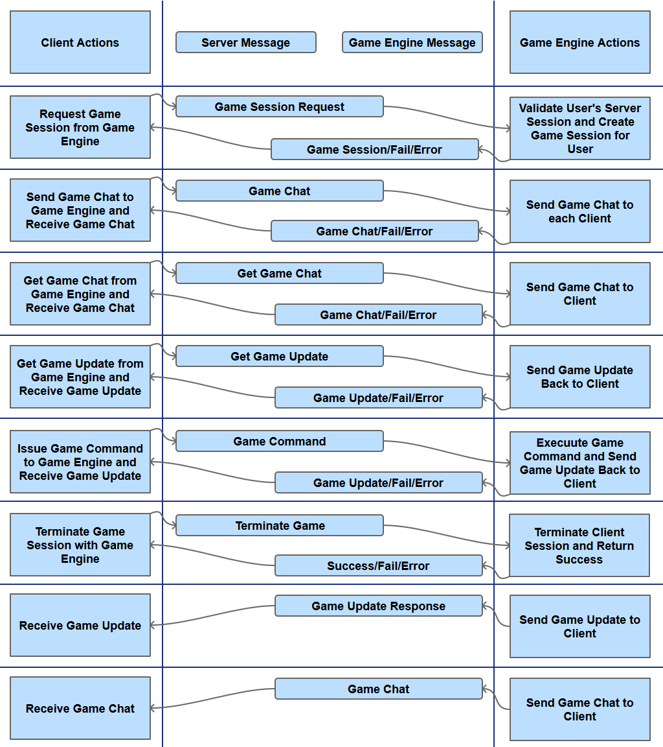

## Client-Server Protocol

**ToDo:**

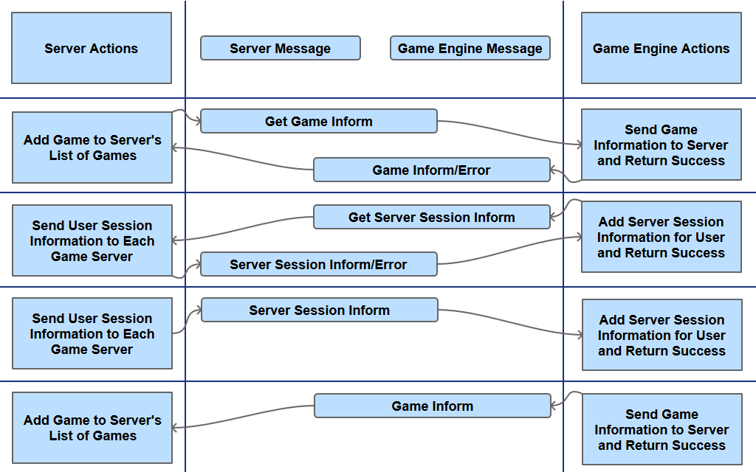

# Discussion of Implementation

**ToDo:**

# Problems Encountered

**ToDo:**

Poor Documentation

HTTPClient

Python

Tornado

Text vs dictionary

Tornado TCP Socket

Integration with HTTP and websockets

Database

Extra information added to documents

Documents are not unique

# What was Learned?

**ToDo:**

# Appendix I – Original Proposal

Michael Richardson

December 27, 2013

CS 4670

## Project Proposal

### Abstract

The project is to build a multi-platform space-themed game with a modular architecture and elements of gameplay for both entertainment and education. My portion of the project is to define requirements, design, build and test a server to run on a Linux machine and clients to run on various platforms including web and mobile to play the space game. I will be implementing an early prototype of the game to test the clients and server.

### Detailed Description

This is a long-term project spanning multiple semesters with a modular architecture so students can work on modules independently or as part of a research group. The game will have a space theme and will incorporate aspects of role-playing, strategy, and 4x games (explore, expand, exploit, and exterminate).

My portion of the project is to define requirements, design, build and test libraries for clients and a server with a database for players, characters, and world (setting) information. The server will be written in python and will need to support HTTP traffic as well as sockets and web sockets. The database will store data as JSON objects in MongoDB. The API for the server will adhere to principles of HATEOAS and REST. I will be creating a central server program with libraries for database, communication and game logic.

The communication libraries will be built to support socket connections, JSON traffic and elements of the API and protocol(s). The protocol will include definitions of the types of data and their properties. TCP socket connections for both HTTP and real-time traffic. Players will be able to use a variety of clients including: desktop applications, native mobile applications, desktop and mobile browsers and SMS. These clients may use 3D graphics, 2D graphics, ASCII Graphics or just text, depending on the type of client and available network bandwidth. Some parts of the game will not be accessible every client (SMS being particularly limited).

I will develop a desktop client for Windows, one or more mobile clients and a web (browser) client. The desktop client will be using Visual Studio 2013 to build either be a console application or a WPF application. The mobile client will be will be built for Windows Modern, Windows Phone or Android. The browser client will be built to be compatible with all major desktop browsers (Chrome, Safari, Firefox and Internet Explorer).

The early prototype of the space-themed game will allow players to move around a map, collect items, achieve some victory condition and communicate real-time with other players. The objective of the server and client is to demonstrate the functionality of the libraries and protocol. Git will provide version control for all the project source code and documentation. The Source code will be released as open source under the Apache License.

### Applicable Tools, Platforms and Standards

* Server
  + Linux
  + Sublime Text
  + Python
  + MongoDB
* Clients
  + Android*
    - Eclipse **or** IntelliJ
    - Java
    - Phone
    - Tablet
  + Windows Metro/Modern
    - Visual Studio 2013
    - C# **or** JavaScript
    - XAML **or** HTML and CSS
  + Web
    - Chrome
    - Firefox
    - Safari
    - Internet Explorer
    - JavaScript
    - HTML
    - CSS
    - Intel XDK
  + Windows Application
    - Console App
    - WPF App
    - Visual Studio 2013
    - C#
    - XAML
* Other
  + NotePad++
  + REST
  + JSON
  + HATEOAS

### Licensing

The source code will be licensed under the Apache License, Version 2.0 as follows:

Copyright 2014 Michael Richardson

Licensed under the Apache License, Version 2.0 (the "License");

you may not use this file except in compliance with the License.

You may obtain a copy of the License at

http://www.apache.org/licenses/LICENSE-2.0

Unless required by applicable law or agreed to in writing, software

distributed under the License is distributed on an "AS IS" BASIS,

WITHOUT WARRANTIES OR CONDITIONS OF ANY KIND, either express or implied.

See the License for the specific language governing permissions and

limitations under the License.

### Proposed Deliverables

1. Source Code (GIT Repository)
2. Communication Libraries and Documentation (Finished and Polished)
3. Multi-platform game (Prototype)
4. Mobile Client (Prototype)
5. Web Client (Prototype)
6. Desktop Client (Prototype)
7. Server (Prototype)
8. Final Project Report
9. Oral Presentation
10. Daily Journal/Work Log
11. Any other relevant items

### Project Schedule

January 6 – Classes Begin

January 13 – Gather and define requirements

January 20 – Design game and API

January 27 – Build Server communication library

February 3 – Build Server communication library

February 10 – Build Client communication libraries

February 17 – Build Client communication libraries

February 24 – Build Client communication libraries

March 3 – Build Client communication libraries

March 10 – Implement database

March 17 – Implement game prototype

March 24 – Implement game prototype

March 31 – Testing

April 7 – Prepare final report and presentation

April 14 – Prepare final report and presentation

April 21 – Prepare final report and presentation

April 25 – Classes end

### Project Details

**Advisor:** Brian Durney

**Completion Semester:** Spring 2014

# Appendix II – Work Log

ToDo:

# Appendix III – Requirements

**ToDo:**

# Appendix IV – JSON Messages

JSON Messages

Server – Game Engine 3

Server Session Inform (Server to Game Engine) 3

Get Session Inform (Game Engine to Server) 3

Game Inform (Game Engine to Server) 3

Get Game Inform (Server to Game Engine) 3

Success (Game Engine to Server) 4

Error (Game Engine to Server) 4

Success (Server to Game Engine) 4

Error (Server to Game Engine) 4

Client – Game Engine 5

Game Session Request (Client to Game Engine) 5

Game Session (Game Engine to Client) 5

Game Chat Message (Client to Game Engine | Game Engine to Clients) 5

Get Game Chat Message (Client to Game Engine) 5

Get Game Update (Client to Game Engine) 5

Game Update (Game Engine to Client) 6

Game Command (Client to Game Engine) 6

Terminate Game (Client to Game Engine) 6

Success (Game Engine to Client and Server) 6

Fail (Game Engine to Client and Server) 6

Error (Game Engine to Client and Server) 7

Client – Server 8

Server Session Request (Client to Server) 8

Server Session (Server to Client) 8

Server Chat Message (Client to Server | Server to Clients) 8

Get Server Chat Message (Client to Server) 8

Get Game List (Client to Server) 8

Game List (Server to Client) 9

Terminate Session (Client to Server) 9

Success (Server to Client and Game Engine) 9

Fail (Server to Client and Game Engine) 9

Error (Server to Client and Game Engine) 10

## Server – Game Engine

### Server Session Inform (Server to Game Engine)

|  |
| --- |
| {  "Type": "Session Inform",  "Sessions": {},  "Source": "Server"  } |

### Get Session Inform (Game Engine to Server)

|  |
| --- |
| {  "Type": "Get Session Inform",  "Source": "Game Engine"  } |

### Game Inform (Game Engine to Server)

|  |
| --- |
| {  "Type": "Game Inform",  "Ip": "127.0.0.1",  "Port": 6500,  "GameInfo": {  "Title": "Game 1",  "Network": {  "IP Address": "127.0.0.1",  "URL": "localhost",  "Port": 6500,  "Communication": "HTTP",  },  "Parameters": {  "Minimum Players": 2,  "Maximum Players": 8,  "Current Players": 4  },  },  "Source": "Game Engine"  } |

### Get Game Inform (Server to Game Engine)

|  |
| --- |
| {  "Type": "Get Game Inform",  "Source": "Server"  } |

### Success (Game Engine to Server)

|  |
| --- |
| {  "Type": "Success",  "Command": "",  " Message ": "",  "Source": "Game Engine"  } |

### Error (Game Engine to Server)

|  |
| --- |
| {  "Type": "Error",  "Command": "",  "Message": "",  "Source": "Game Engine"  } |

### Success (Server to Game Engine)

|  |
| --- |
| {  "Type": "Success",  "Command": "request type",  " Message ": "",  "Source": "Server"  } |

### Error (Server to Game Engine)

|  |
| --- |
| {  "Type": "Error",  "Command": "Chat",  "Message": "",  "Source": "Server"  } |

## Client – Game Engine

### Game Session Request (Client to Game Engine)

|  |
| --- |
| {  "Type": "Game Session Request",  "Username": "user",  "SessionNumber": 123,  "Source": "Client"  } |

### Game Session (Game Engine to Client)

|  |
| --- |
| {  "Type": "Game Session",  "SessionNumber": 123,  "PlayerName": "player",  "Player": {  "Name": "player",  "History": []  },  "Source": "Game Engine"  } |

### Game Chat Message (Client to Game Engine | Game Engine to Clients)

|  |
| --- |
| {  "Type": "Game Chat",  "SessionNumber": 123,  "PlayerName": "player",  "Message": "user message",  "Status": "active",  "Source": "Client"  } |

### Get Game Chat Message (Client to Game Engine)

|  |
| --- |
| {  "Type": "Get Game Chat",  "SessionNumber": 123,  "PlayerName": "player",  "Source": "Client"  } |

### Get Game Update (Client to Game Engine)

|  |
| --- |
| {  "Type": "Get Game Update",  "SessionNumber": 123,  "PlayerName": "player",  "Source": "Client"  } |

### Game Update (Game Engine to Client)

|  |
| --- |
| "Game Update":{  "SessionNumber": 123,  "PlayerName": "player",  "Update": {},  "Source": "Game Engine"  } |

### Game Command (Client to Game Engine)

|  |
| --- |
| {  "Type": "Game Command",  "SessionNumber": 123,  "PlayerName": "player",  "Command": {},  "Source": "Client"  } |

### Terminate Game (Client to Game Engine)

|  |
| --- |
| {  "Type": "Terminate Game",  "SessionNumber": 123,  "PlayerName": "player",  "Source": "Client"  } |

### Success (Game Engine to Client and Server)

|  |
| --- |
| {  "SessionNumber": 123,  "PlayerName": "player",  "Type": "Success",  "Command": "request type",  " Message ": "",  "Source": "Game Engine"  } |

### Fail (Game Engine to Client and Server)

|  |
| --- |
| {  "SessionNumber": 123,  "PlayerName": "player",  "Type": "Fail",  "Command": "request type",  " Message ": "",  "Source": "Game Engine"  } |

### Error (Game Engine to Client and Server)

|  |
| --- |
| {  "SessionNumber": 123,  "PlayerName": "player",  "Type": "Error",  "Command": "Chat",  "Message": "",  "Source": "Game Engine"  } |

## Client – Server

### Server Session Request (Client to Server)

|  |
| --- |
| {  "Type": "Server Session Request",  "Username": "user",  "Password": "password hash",  "Source": "Client"  } |

### Server Session (Server to Client)

|  |
| --- |
| {  "Type": "Server Session",  "SessionNumber": 123,  "Username": "user",  "Source": "Server"  } |

### Server Chat Message (Client to Server | Server to Clients)

|  |
| --- |
| {  "Type": "Server Chat",  "SessionNumber": 123,  "Username": "user",  "Message": "user message",  "Status": "active",  "Source": "Client"  } |

### Get Server Chat Message (Client to Server)

|  |
| --- |
| {  "Type": "Get Server Chat",  "SessionNumber": 123,  "Username": "user",  "Source": "Client"  } |

### Get Game List (Client to Server)

|  |
| --- |
| {  "Type": "Get Game List",  "SessionNumber": 123,  "Username": "user",  "Platform": "iPhone",  "Features": [],  "Source": "Client"  } |

### Game List (Server to Client)

|  |
| --- |
| {  "Type": "Game List ",  "SessionNumber": 123,  "Username": "user",  "Games":[  "Game": “Game 1”,  "Game": “Game 2”,  "Game": “Game 3”,  "Game": “Game 4”  ] ,  "Source": "Server"  } |

### Terminate Session (Client to Server)

|  |
| --- |
| {  "Type": "Terminate Session",  "SessionNumber": 123,  "Username": "user",  "Source": "Client"  } |

### Success (Server to Client and Game Engine)

|  |
| --- |
| {  "Type": "Success",  "SessionNumber": 123,  "Username": "user",  "Command": "request type",  " Message ": "",  "Source": "Server"  } |

### Fail (Server to Client and Game Engine)

|  |
| --- |
| {  "Type": "Fail",  "SessionNumber": 123,  "Username": "user",  "Command": "request type",  " Message ": "",  "Source": "Server"  } |

### Error (Server to Client and Game Engine)

|  |
| --- |
| {  "Type": "Error",  "SessionNumber": 123,  "Username": "user",  "Command": "Chat",  "Message": "",  "Source": "Server"  } |

# Appendix V – JSON Objects

JSON Objects

Server 2

Game Engines 2

Game Engine 2

Sever Sessions 2

Server Session 2

Users 2

User 2

Game Information List 2

Game Information 3

Server Chat Messages 4

Server Chat Message 4

Game Engine 5

Sever Sessions 5

Server Session 5

Game Sessions 5

Game Session 5

Players 5

Player 5

Game 6

Game Updates 6

Game Update 6

Game Information 6

Game Chat Messages 6

Game Chat Message 7

Client 8

Game Command 8

## Server

### Game Engines

|  |
| --- |
| {  {"GameEngine": {"Ip": "127.0.0.1", "Port": 6500}},  {"GameEngine": {"Ip": "127.0.0.1", "Port": 6500}}  } |

### Game Engine

|  |
| --- |
| {"Ip": "127.0.0.1", "Port": 6500} |

### HTTP Clients

|  |
| --- |
| {  {"HTTPClient": {"Ip": "127.0.0.1", "Port": 6500}},  {"HTTPClient": {"Ip": "127.0.0.1", "Port": 6500}}  } |

### HTTP Client

|  |
| --- |
| {"Ip": "127.0.0.1", "Port": 6500} |

### Sever Sessions

|  |
| --- |
| {  {"Session": {"SessionNumber": 123, "Username": "user"}, "SessionNumber": 123},  {"Session": {"SessionNumber": 123, "Username": "user"}, "SessionNumber": 123}  } |

### Server Session

|  |
| --- |
| {"SessionNumber": 123, "Username": "user"} |

### Users

|  |
| --- |
| {  {"User": {"Username": "user", "Password": "password"}, "Username": "user"},  {"User": {"Username": "user", "Password": "password"}, "Username": "user"}  } |

### User

|  |
| --- |
| {"Username": "user", "Password": "password"} |

### Game Information List

|  |
| --- |
| {  {  "Title": "Game 1",  "GameInformation":  {  "Title": "Game 1",  "Network":  {  "Ip": "127.0.0.1",  "URL": "localhost",  "Port": 6500,  "Communication": "HTTP",  },  "Parameters":  {  "Minimum Players": 2,  "Maximum Players": 8,  "Current Players": 4  }  }  },  {  "Title": "Game 1",  " GameInformation ":  {  "Title": "Game 2",  "Network":  {  "Ip": "127.0.0.1",  "URL": "localhost",  "Port": 6500,  "Communication": "HTTP",  },  "Parameters":  {  "Minimum Players": 2,  "Maximum Players": 8,  "Current Players": 4  }  }  }  } |

### Game Information

|  |
| --- |
| {  "Title": "Game 2",  "Network":  {  "IP Address": "127.0.0.1",  "URL": "localhost",  "Port": 6500,  "Communication": "HTTP",  },  "Parameters":  {  "Minimum Players": 2,  "Maximum Players": 8,  "Current Players": 4  }  } |

### Server Chat Messages

|  |
| --- |
| {  {  "SessionNumber": 123,  "ChatMessage":  {  "Type": "Server Chat",  "SessionNumber": 123,  "Username": "user",  "Message": "user message",  "Status": "active",  "Source": "Server"  }  },  {  "SessionNumber": 123,  "ChatMessage":  {  "Type": "Server Chat",  "SessionNumber": 123,  "Username": "user",  "Message": "user message",  "Status": "active",  "Source": "Server"  }  }  } |

### Server Chat Message

|  |
| --- |
| {  "Type": "Server Chat",  "SessionNumber": 123,  "Username": "user",  "Message": "user message",  "Status": "active",  "Source": "Server"  } |

## Game Engine

### HTTP Clients

|  |
| --- |
| {  {"HTTPClient": {"Ip": "127.0.0.1", "Port": 6500}},  {"HTTPClient": {"Ip": "127.0.0.1", "Port": 6500}}  } |

### HTTP Client

|  |
| --- |
| {"Ip": "127.0.0.1", "Port": 6500} |

### Sever Sessions

|  |
| --- |
| {  {{"SessionNumber": 123, "Username": "user"}, "SessionNumber": 123},  {{"SessionNumber": 123, "Username": "user"}, "SessionNumber": 123}  } |

### Server Session

|  |
| --- |
| {"SessionNumber": 123, "Username": "user"} |

### Game Sessions

|  |
| --- |
| {  {{"SessionNumber": 123, "PlayerName": "player"}, "SessionNumber": 123},  {{"SessionNumber": 123, "PlayerName": "player"}, "SessionNumber": 123}  } |

### Game Session

|  |
| --- |
| {"SessionNumber": 123, "PlayerName": "player"} |

### Players

|  |
| --- |
| {  {  "PlayerName": "player",  "Player":  {  "PlayerName": "player",  . . .  }  },  {  "PlayerName": "player",  "Player":  {  "PlayerName": "player",  . . .  }  }  } |

### Player

|  |
| --- |
| {  "PlayerName": "player",  . . .  } |

### Game

|  |
| --- |
| {  . . .  } |

### Game Updates

|  |
| --- |
| {  {"SessionNumber": 123, "GameUpdate": { . . . }},  {"SessionNumber": 123, "GameUpdate": { . . . }}  } |

### Game Update

|  |
| --- |
| {  . . .  } |

### Game Information

|  |
| --- |
| {  "Title": "Game 1",  "Network":  {  "IP Address": "127.0.0.1",  "URL": "localhost",  "Port": 6500,  "Communication": "HTTP",  },  "Parameters":  {  "Minimum Players": 2,  "Maximum Players": 8,  "Current Players": 4  }  } |

### Game Chat Messages

|  |
| --- |
| {  {  "SessionNumber": 123,  "ChatMessage":  {  "Type": "Game Chat",  "SessionNumber": 123,  "Username": "user",  "Message": "user message",  "Status": "active",  "Source": "Server"  }  },  {  "SessionNumber": 123,  "ChatMessage":  {  "Type": "Game Chat",  "SessionNumber": 123,  "Username": "user",  "Message": "user message",  "Status": "active",  "Source": "Server"  }  }  } |

### Game Chat Message

|  |
| --- |
| {  "Type": "Game Chat",  "SessionNumber": 123,  "Username": "user",  "Message": "user message",  "Status": "active",  "Source": "Server"  } |

## Client

### Game Command

|  |
| --- |
| {  . . .  } |

# Appendix VI – Presentation

**ToDo:**